**CARBON BLACK**

**HERO**



Carbon black is a fine, black powder widely used in the production of rubber, plastics, inks, and coatings. Known for its high surface area and tendency to fluidize, it requires careful handling to maintain safety and efficiency. Flexicon bulk material handling systems are engineered to move carbon black cleanly and reliably across all stages of production.

**Button**: Talk To Us

**SHELF #1 - PRODUCT DESCRIPTION**

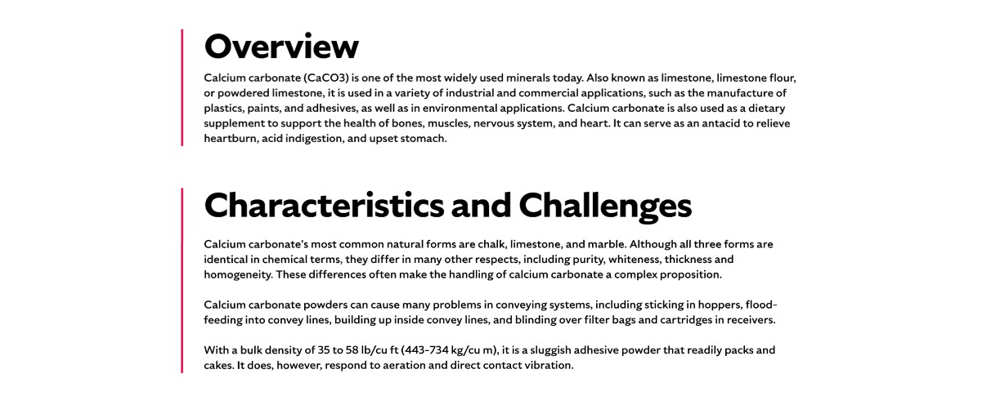

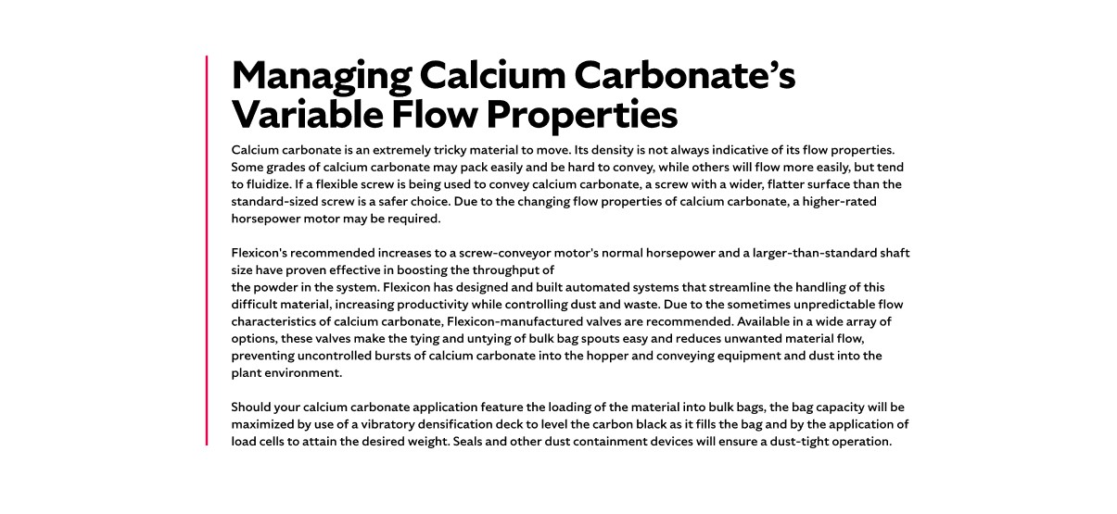

**Overview**

Carbon black is an inorganic, colloidal material produced through the incomplete combustion of petroleum-based products. Depending on the manufacturing process, it may also be referred to as lamp black, furnace black, acetylene black, channel black, thermal black, or gas black. It is widely used as a reinforcing agent in rubber products, a pigment in inks and paints, and a conductive filler in electronic components. Carbon black’s broad industrial applications make it indispensable, but its unique flow characteristics and health considerations require specialized handling equipment.

**Characteristics and Challenges**

Carbon black is extremely fine, lightweight, and tends to fluidize, meaning the fine carbon black particles take on characteristics of a liquid. It is insoluble in water and most solvents, and its high surface area allows it to adsorb moisture and vapors easily. With a bulk density ranging from 1.8 to 2.1 g/cm³ and a high surface-area-to-volume ratio, it is highly effective in applications requiring pigmentation, reinforcement, or conductivity.

Carbon black poses several handling and safety challenges. It cakes and packs easily, and its tendency to fluidize causes fine particles to behave like a liquid, often leading to buildup and deposits in conveying lines. Prolonged exposure to carbon black dust may cause respiratory irritation, skin dryness, and has been linked to potential carcinogenic effects. To mitigate these risks, carbon black should be handled in dust-tight systems and stored in clean, dry, sealed containers away from high heat, open flames, and strong chemical vapors. Some grades may also contain trace amounts of adsorbed carbon monoxide, requiring confined space entry procedures to include gas monitoring. Preventing spills and ensuring proper cleanup protocols are also essential for maintaining a safe work environment.

**SHELF #2 - FLEXICON SOLUTIONS**

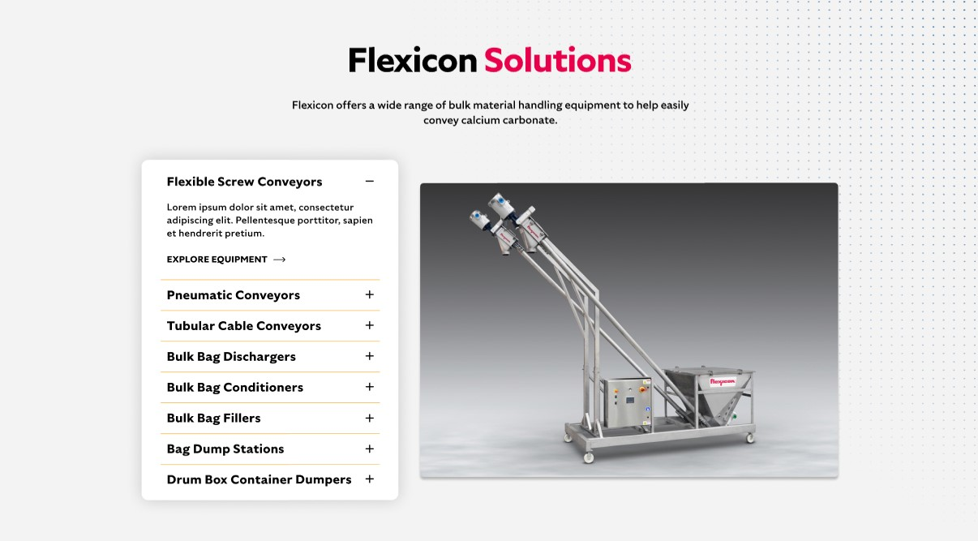

**Flexicon Solutions**

Flexicon offers a wide range of bulk material handling equipment to help easily convey calcium carbonate.

* **Flexible Screw Conveyor**: Effectively transport carbon black powders that tend to clump or fluidize, maintaining product integrity throughout the process.
* **Pneumatic Conveyors**: Fully enclosed systems capture and recycle carbon black dust, supporting clean, continuous movement with minimal loss.
* **Tubular Cable Conveyors**: Ideal for tight layouts, these enclosed systems move carbon black gently and cleanly through complex plant configurations.
* **Bulk Bag Dischargers**: Designed for dust-free unloading, these units ensure smooth, controlled flow of carbon black from bulk bags into your process line.
* **Bulk Bag Conditioners**: Break up hardened carbon black inside bulk bags to restore flowability and prevent discharge interruptions.
* **Bulk Bag Fillers**: Deliver precise, dust-controlled filling of bulk bags with carbon black, optimizing weight accuracy and workplace cleanliness.
* **Bag Dump Stations**: Provide a safe, ergonomic solution for manually adding carbon black to your system while minimizing airborne particles.
* **Drum Box Container Dumpers**: Streamline the transfer of carbon black from smaller containers into processing equipment with reduced dust and labor effort.

**SHELF #3: LIFETIME PERFORMANCE GUARANTEE**

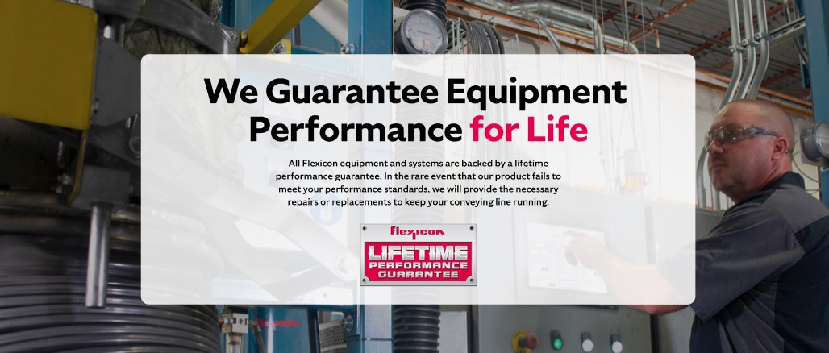

**Lifetime Performance Guarantee**

All Flexicon equipment and systems are backed by a lifetime performance guarantee. In the rare event that our product fails to meet your performance standards, we will provide the necessary repairs or replacements to keep your conveying line running.

**SHELF #4: CASE STUDIES**

